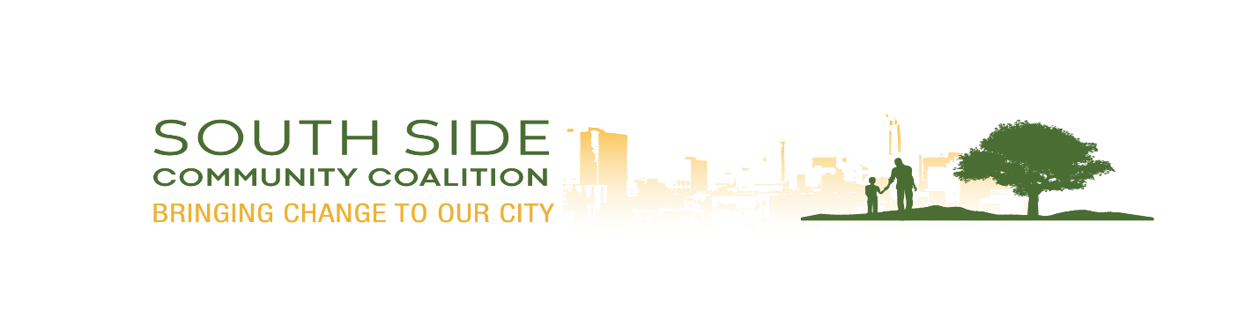 | South Side Community Coalition  20 Years  “Times flies when you having Fun”  Summer 2023 Meijer Gardens  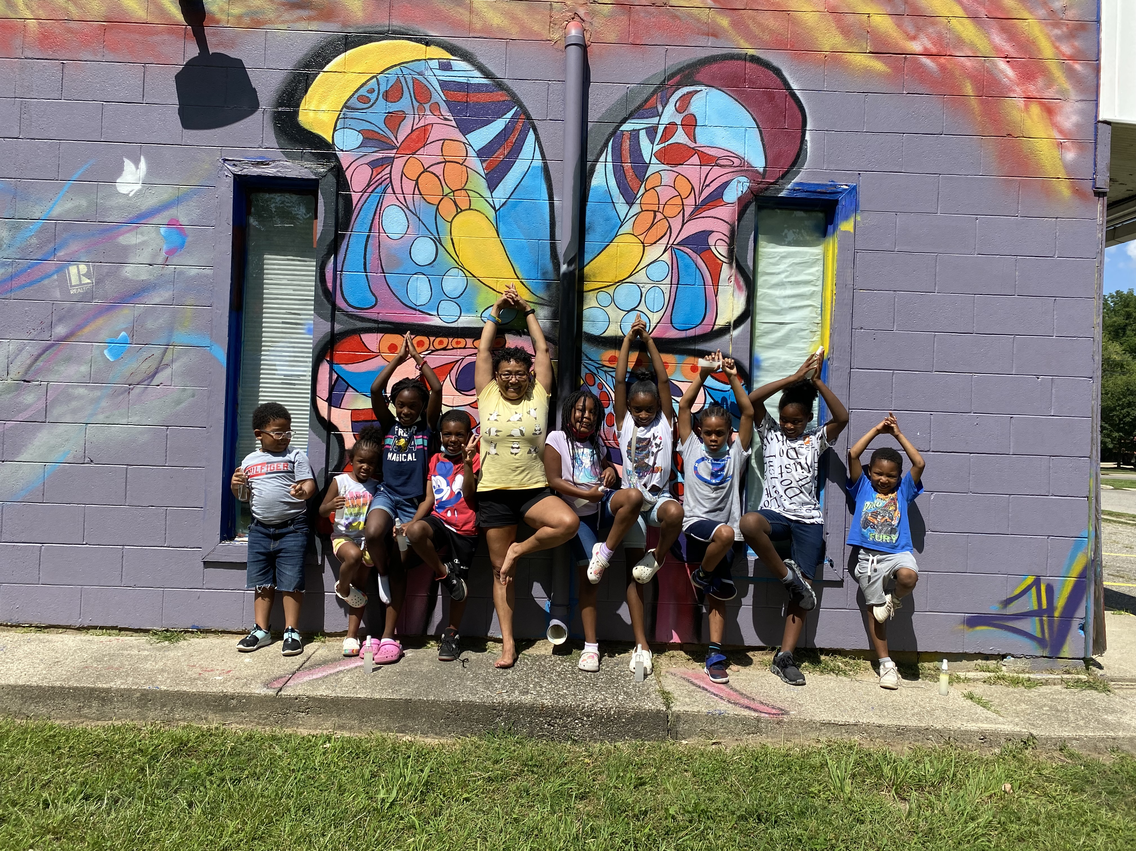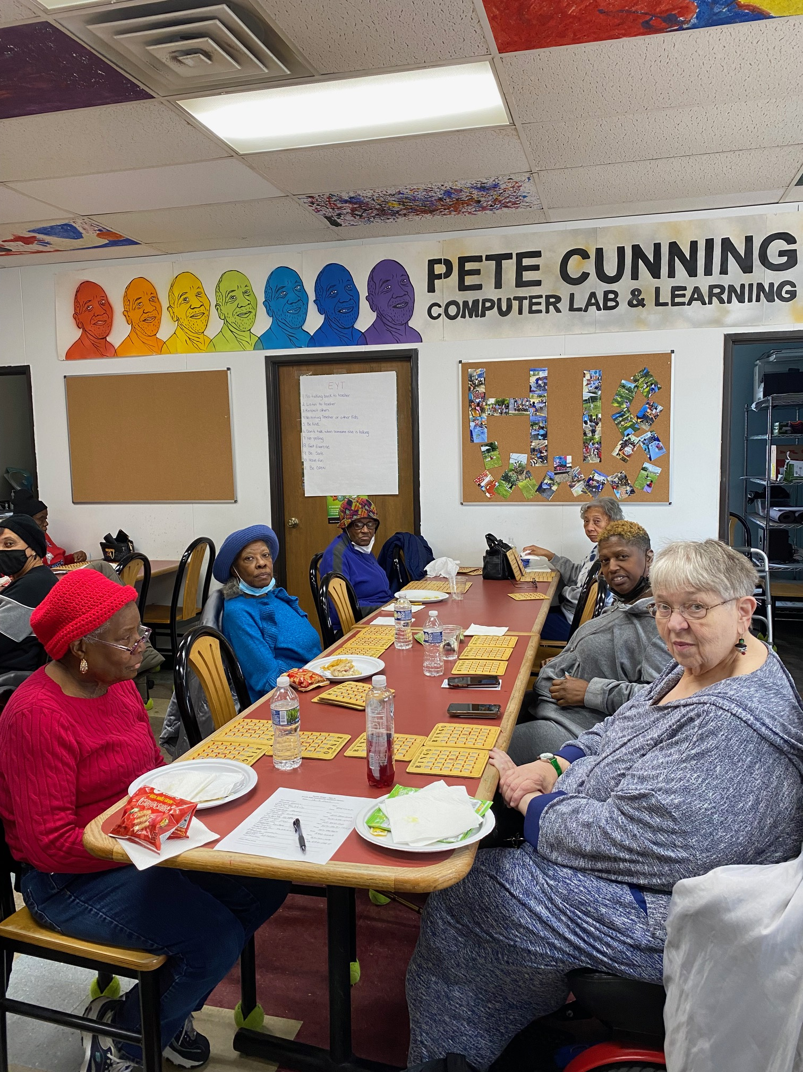  Senior Bingo Yogi  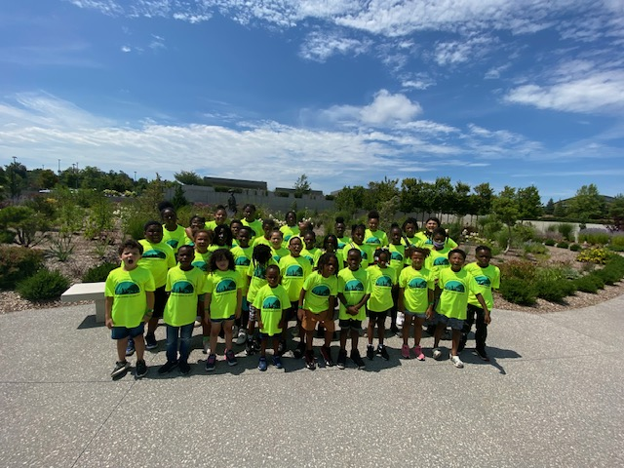

South Side 20 Years
Over twenty years ago a group of community leaders, teachers and City of Lansing officials got together to talk about starting a program for young people on the Southside of Lansing.
One of the community leaders was Frank Curtis X who used to come to the City Council meetings every week and speak about the need for a community center on the south side of Lansing.
After a year of discussions and planning, the group, which called itself a Coalition, organized a summer program for high school students at Hill High School. The City and the School district provided funding for teachers and programs.
Cordell Henderson, a current Board member, and Gordon Wilson, a former Board member, helped oversee the program. The Coalition hired Pete Cunningham to help run the program.
After two summers, the Coalition decided to open up a full service community center. They said that they wanted programs not just for high school students, but for all students, as well as for their families and for senior citizens.
Gordon and Pete and other from the Board found our building in 2004. (It had been a Quality Dairy, but they moved down the street.) The Board members helped fix up the building and we moved into the building in the Spring of 2004. Mayor Tony Benavides and Frank Curtis X cut the ribbon to open the Center.
Pete Cunningham was our Director and Gordon Wilson was our Board President. The City of Lansing gave us a grant to run our programs which were primarily after-school programs, a summer program and a senior program. Just like we have to this day.
We also used Americorp VISTA members to help run our programs. That’s how Yolanda Williams came to the Center. She has been with the Center for almost 18 years and has helped build up the programs and make them successful.
After a few years, the Coalition got a grant from the Ingham County Health Department to register people for health care programs, including the Ingham County Health Plan. We hired two staff people to run that program, but now Ms. Yolanda runs that program also.
Over the years, we have added our senior program, our hoop house and garden program, our food programs, our after school program, our summer program and our Empower Youth today program.
We have partnered with the City in developing Beacon Park and we work with the Southwest Action Group to improve our neighborhood.
Thank you everyone who has participated in our programs over the years and helped make the Southside Community Coalition a wonderful place for children, teens, seniors and families.
Board of Director
Ann Blair
Ann was a teacher and principal in the Lansing School District. She is also an officer of the South Lansing Kiwanis Club. She has raised money for Southside from the Club. She has also taught the program Terrific Kids at the Center.
Stuart Chavis
Stuart has been a member of the Board for the past five years. He was also our director for one year. He has helped the Center in many ways.
Courtney Cole
Courtney is the newest (and youngest) member of the Board. She is our secretary and has worked on our website and designed fliers for our special events – such as this anniversary celebration.
Cordell Henderson
Cordell was the principal of Hill High School which was the first location of the Southside Community Coalition when we had a summer high school program. He is a founding member of the Coalition.
Murdock Jemerson
Murdock was the Director of the City of Lansing Parks and Recreation Department when the Coalition was founded. He is a founding member of the Coalition. Murdock is also a photographer and has taken many pictures of the Coalition activities over the years. He has also helped get food donations for our holiday food baskets.
Joe Salter
Joe is also a relatively new member of the Board. He was a CATA bus driver during his career. He has helped the Center with our food program and when we need volunteers for various programs and events.
Laurin Thomas
Laurin has been a Board member for about ten years and has helped the Coalition in many ways, including being a secretary and helping get the solar panels on our roof.
Cathy Scott Lynch
Cathy is our Board President and helps oversee the on-going operations of the Center as well as supporting the staff, especially Miss Yolanda, in their work. She has also been a leader of the Board in helping make decisions. She is a founding member of the Coalition.
David Wiener
Dave is our Board Treasurer and helps keep track of our revenues and expenses as well as the grants and donations we receive. He also helps with the hoop house and garden. Dave is a founding member of the Coalition.

- Contact Us  South Side Community Coalition  2101 W Holmes Road  Lansing, MI 48910  517-394-7400 Main Line  517-394-3138 Fax  Outreach.sscc@gmail.com  www.southsidecommunitycoalition.com | Upcoming Event  September 2023  Senior BINGO –  Wednesday September 20, 2023  Wednesday September 27, 2023  12:00-1:30 p.m.  Senior Luncheon-  September 28, 2023  12:30-2:00 p.m.  October 2023  Senior BINGO-  Wednesday, October 4, 2023  Wednesday, October 11, 2023  12:30-2:00 p.m.  Senior Movie Day  Friday, October 20, 2023  11:00 – 1:00 p.m.  Senior Luncheon  Thursday, October 26, 2023  12:30-2:00 p.m.  November 2023  Senior BINGO-  Wednesday, November 1, 2023  Wednesday, November 8, 2023  12:30-2:00 p.m.  Senior Luncheon  Thursday, November 16, 2023  12:30-2:00 p.m.

