“ Surviving Covid – 19”

Southside Community Coalition

June, July, & August 2021

CDC – Guidelines

Avoid crowds and poorly ventilated spaces



Wash your hands often



Clean and disinfect



Wear a mask



Stay 6 feet away from others

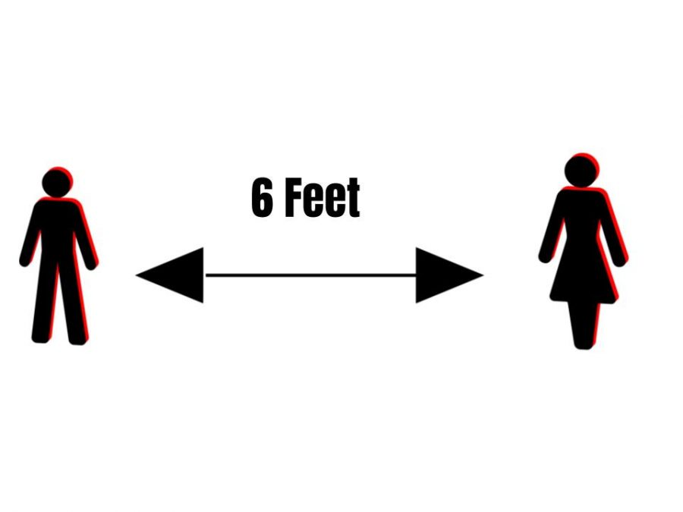

Get Vaccinated



Cover coughs and sneezes



**Update on Beacon Park – Southside Community Coalition – May 2021**

**Southside has been working with the City of Lansing on developing the new Beacon Park. As you probably know, the Beacon Soccer Field was installed in the Fall of 2019. Since then it has been a magnet for young soccer players from Southwest Lansing. Many local companies, the City, the County and many individuals contributed to making the Beacon Soccer field a reality.**

**We worked with Jackson National Life and many volunteers, including Mayor Schor, State Representative Sarah Anthony, County Commissioner Derrell Slaughter and City Council member Adam Hussein to build the KaBOOM! Playground.**

**This past Fall 2020 the walking trail was completed. This also was the result of the contributions of many companies and individuals.**

**The next phase of the development of the Park will be the installation of an archway entrance from Pleasant Grove Avenue (across from the new Town Square and sculpture). This will be installed in conjunction with a decorative CATA bus stop bench in late summer or early Fall. We want to acknowledge and thank the Ingham County Invest Health Project which provided funding for this beautiful art work and Dane Vermeulen and Michigan Imagery who designed and constructed it.**

**We also received a grant from the Mayor’s Neighborhood Grant program to install trees, shrubs and perennials along the eastern boundary of the Park. We will begin that work in May and complete it in the Fall.**

**We want to acknowledge and thank The Kiwanis Club of Lansing (this is the Downtown Kiwanis Club) for their generous contribution to help fund the Soccer Field and the Trail. Their contribution was in honor of their 100th anniversary. The Kiwanis Club of Lansing has also provided work parties to help keep the park clear of brush and to help with plantings.**

**We have more projects planned for the Park, but we have come a long way in the past four years since we started clearing the fallen trees, brush and trash that covered the three acres that is now the park.**

**Come and enjoy the walking trail and bring your children to the playground. It is an wonderful new park for southwest Lansing.**

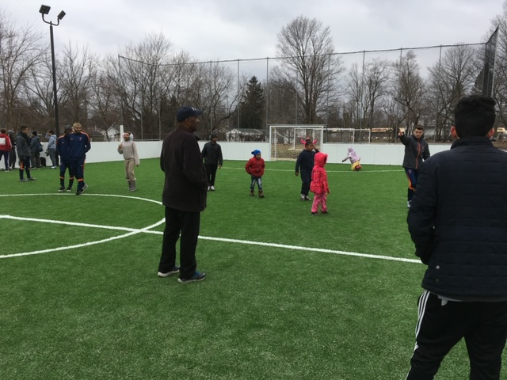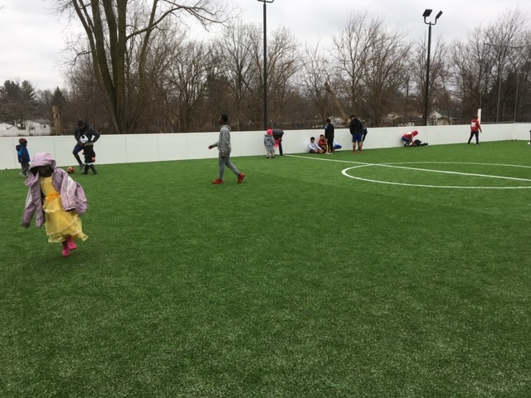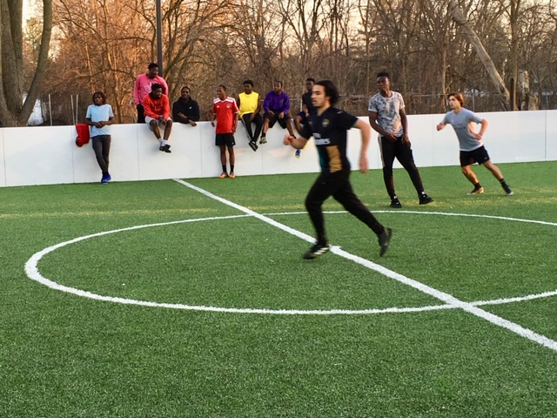

**Communities In Schools of Michigan**

**What Is It?**

Each month a new, carefully selected book will be mailed in your child’s name directly to your home. The first book is always the children’s classic The Little Engine That Could™. Best of all it is a FREE GIFT to your child through our partnership with local organizations! There is no cost or obligation to your family.

**Who Is Eligible?**

Children under the age of five

**What Are My Responsibilities?**

1. Be a resident of 48906, 48911, 48915, or 48933

2. Submit an official registration form, completely filled out by the authorized adult.

3. Notify any time your address changes. Books are mailed to the address listed on the account. Note: If the child’s address changes, you must contact your friends at the address on this brochure in order to continue receiving books.

4. Read with your child and have fun!

**When Will I Receive Books?**

Eight to ten weeks after your registration form has been received, books will begin arriving at your home and will continue until your child turns five or you move out of the covered area.

Online registration: [www.imaginationlibrary.com/check-availability](http://www.imaginationlibrary.com/check-availability)



**Garden Updates**

Olivia Sinutko, SSCC Healthy Lifestyles Specialist

As it begins to get warmer, SouthSide Community Coalition’s hoop house and garden will be fully planted with vegetables, herbs, and fruits. Earlier in the year we reached out to SSCC youth to ask what they want to see planted in the garden. Using results from those surveys, we planned summer plantings and began starting seeds to grow transplants.

We are currently growing herbs, cabbage, turnips, and greens like lettuce, spinach, and kale in the hoop house. Our strawberry plants are blooming and will begin producing strawberries in the next couple of months. Warmer-season crops like peppers, tomatoes, and cucumbers will be planted in the upcoming weeks. Look out for fresh produce that we harvest outside the center at the free food pantry until regular food distributions begin this summer.

Another project that we are working on is creating garden kits to provide to youth. These garden kits will consist of vegetable, herbs, and flower transplants and other materials you would need to plant your own garden in your yard or on a balcony. Information cards and educational activities will also be provided with the garden kits. Please contact me at [americorpsolivia@gmail.com](mailto:americorpsolivia@gmail.com) or call 248-703-9975 if you are interested in receiving a garden kit.

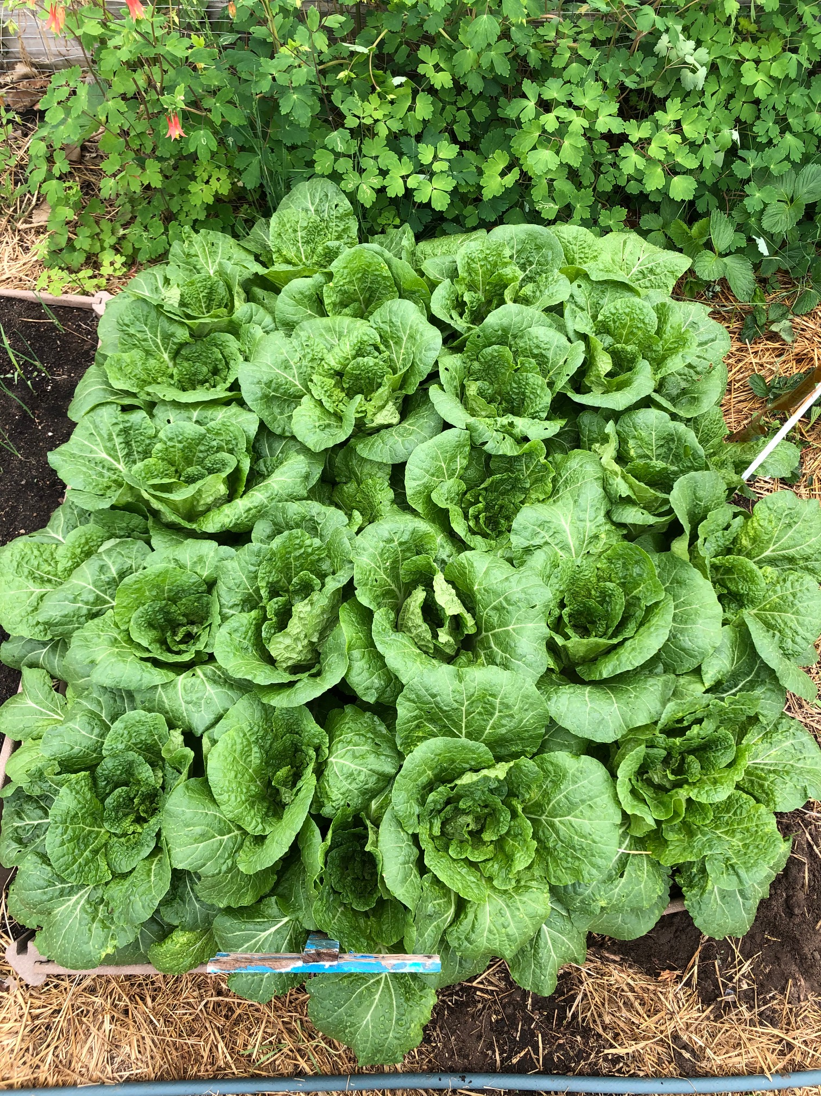

**Southwest Action Group (SWAG) – May, 2021**

The Southside Community Coalition has been an active member of the Southwest Action Group, which is a non-profit neighborhood development organization that brings together merchants from the Pleasant View Plaza, neighborhood organizations, representation from Tabernacle of David and other residents. Our goal is to beautify and develop our area of the City.

You may have noticed the new sculpture that has been installed in the Town Square of the Plaza on Pleasant Grove. This was the culmination of several years of cooperation between SWAG, the City of Lansing Planning and Development Department and the Lansing Art Council and local sculptor David Such. The Lansing Economic Area Partnership (LEAP) also played an important role in helping all of us work out all the details of the project.

There are many people to thank for this accomplishment including: Rachelle White Leigh (President of SWAG and owner of Center of the Plate Catering), Revon Herfy (former President of SWAG and owner of 1910 Market), Adam Hussein (City Council Member), Mayor Schor, BW of BW Hair Salon and Barber Shop, Andy Crawford (former Director of the City Department of Neighborhoods and Citizen Engagement), DeLisa Fountain (current Director of the Department of Neighborhoods and Citizen Engagement), Barbara Kimmell (Community Development Coordinator of the City Department of Development and Planning), Don Kulhanek (Attorney with the City Department of Development and Planning), and Kris Klein (Project Coordinator with LEAP). There are others who planned a key role in the construction of the town square. (If we have missed anyone, let us know and we will recognize you in another article.)

Following the development of the Town Square, Yolanda Williams, our Program Coordinator, worked with the Ingham County Invest Health Project to plan and install the planters along the edge of the parking lot between the parking lot and the stores. She also arranged to have the entire building painted, in addition to the Center of the Plate building and BW’s Hair Salon and Barber Shop.

Thanks goes to Jessica Yorko, of the Ingham County Health Department and coordinator of the Invest Health Project, for helping with the contracts and securing the funding for these projects.

The next major project will be the development of a Health Center and memorial to Malcolm X at the old school on the corner, formerly Hope Academy. We are working with the Ingham County Land Bank, the Ferguson Group and the City on this exciting project. While it will take some time to work out the complex details of this project, stay tuned. We will keep you informed about the progress.

The Long-Haul Spring of 2021

The last year and a half has been tumultuous, strange, confusing and often grim. We at the Southside Community Coalition (SSCC) have been striving to find answers to all of the changes going on around us and the world. We have continued many of our normal activities although in abbreviated, or in virtual computerized forms. Our core staff, Yolanda Williams, and Dezarae Delacruz Jones have worked diligently to help keep our ship afloat and steaming in the correct direction. Under the guidance of the Chair of the Board of Directors, Ms. Cathy Scott Lynch, Vice Chair Ann Blair, Secretary Courtney Cole, the always energetic Treasurer David Wiener, and the rest of the board, SSCC plans on remaining relevant in and to the community around us.

Still, we face challenges, including the ever-present virus transmission concerns, and issues surrounding our senior citizens and children. We have taken forward thinking steps to address these concerns, including having professional sanitization completed in the building and purchasing our own sanitization supplies and equipment. Our hoop house/garden projects continue with success with the assistance of our Americorps worker Olivia Sinutko, and the unstoppable David Wiener, and we have partnered with the city of Lansing, and others to keep our vegetable growing processes strong.

Again, we at SSCC look forward to remaining a center of positive and helpful activities and efforts for a long time to come.

Stuart Chavis, Interim Director

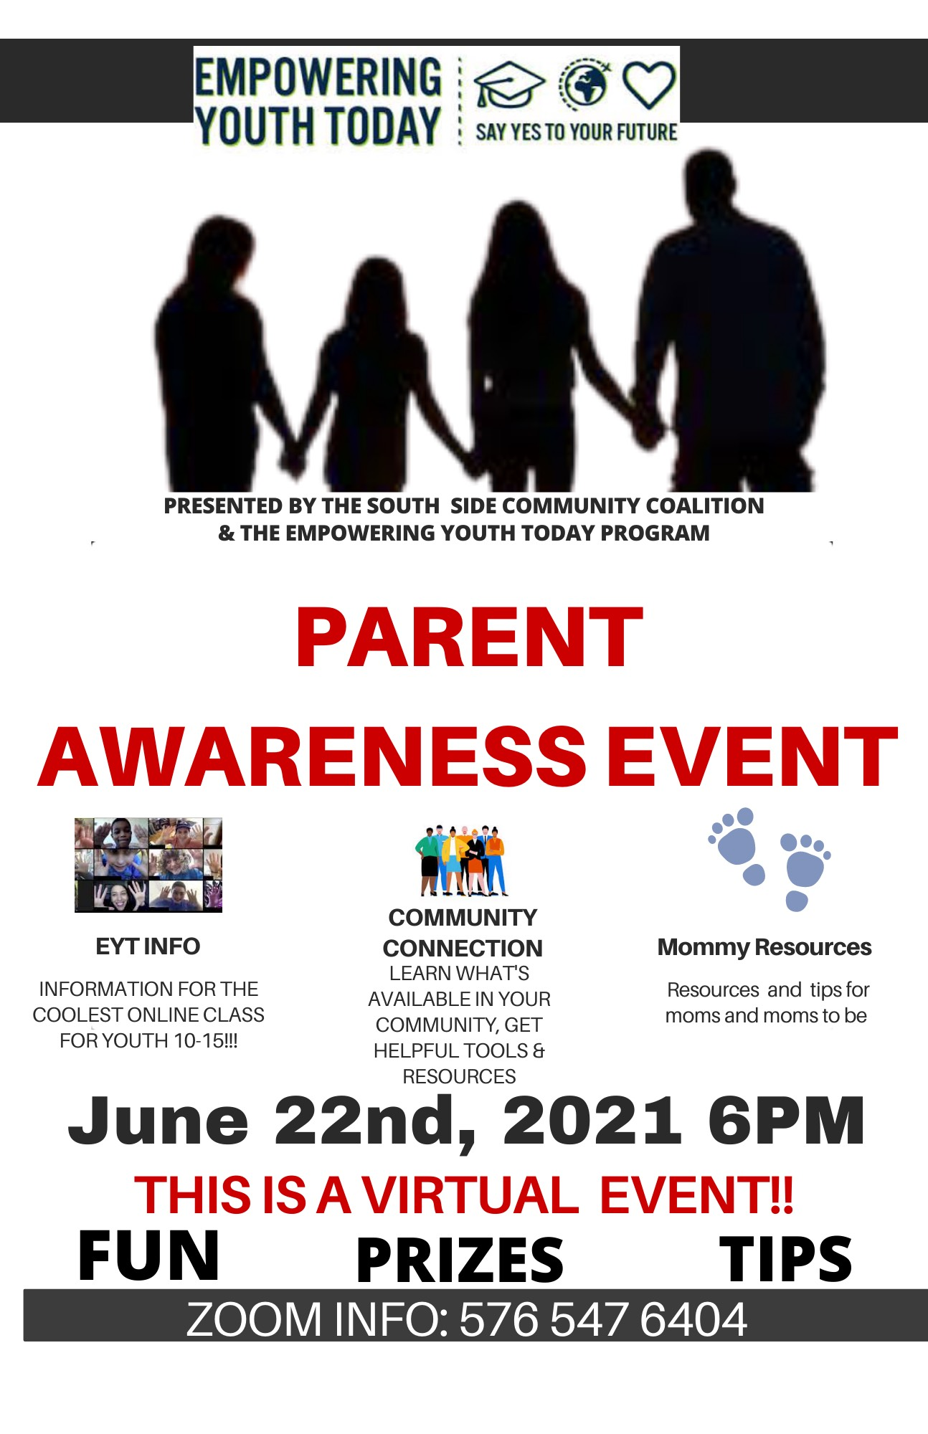

YOUTH EMPOWERMENT PROGRAM IS VIRTUAL!!!

(The Southside Community Coalition and Empowering Youth Today Program) We are honored and excited to be given this great opportunity to increase community awareness about this important issue. Empowering Youth Today is a strength-based, positive youth development program that incorporates sexual risk avoidance education. It aims to provide Michigan youth, ages 10-16, the tools need to plan their future through high school/ college and complete goals without an unplanned pregnancy. The program will also involve fun educational workshops for youth and parents to participate in together as well as community service opportunities.

Virtual sessions are tailored for youth 10-16 M-Thursday for 2-3 weeks. Topics include sexual risk avoidance, overcoming obstacles, goal setting, and overcoming the adolescent years.





Summer

Southside Community Coalition is known for our Wonderful Summer Program. During this difficult time of Covid-19, we don’t at this time know what our summer program will look like, how to bring our youth back to the building and keeping everyone safe. The South Side Community Coalition Board of Director and Staff are working hard to figure out a good way to have a safe and wonderful summer program. SSCC will continue to update you on any new information regarding our summer program

Information will be posted on are Facebook and our Website

[www.southsidecommunitycoalition.com](http://www.southsidecommunitycoalition.com)

**Helping you every step of the way.**

Apply for benefits, manage your case, and explore resources.

If you are interested in using Michigan Bridges to sign up for health care or other services, you can still do so by Phone. Just Call our numbers at 517-394-7400 or

517-394-3138 and someone will help you! Or you can leave a message and someone will get back to you. We know that things are more difficult during these COVID times, but we are still here to help though phone interviews and support.

**Helping Feed Our Community**

CADL has partnered with the [Greater Lansing Food Bank](https://greaterlansingfoodbank.org/)and local pantries to help make food more accessible. Selected branches and the Mobile Library will provide weekly food packs filled with items such as shelf-stable milk, fruit, vegetables, canned meals and more. There are no eligibility requirements. Food packs will be available starting on Monday of each week but pickup times are available throughout the week. Families who need more than one pack must register for each one separately. **To register, call one of the participating branches during regular business hours.**

At this time, all pickups must be scheduled through the library and those picking up food packs must follow current guidelines from the Ingham County Health Department and the Center for Disease Control and Prevention including wearing a mask and social distancing.

**Participating Branches**

[**AURELIUS**](https://www.cadl.org/about/our-locations/aurelius)**:**[517.628.3743](tel:5176283743)

[**DANSVILLE**](https://www.cadl.org/about/our-locations/dansville)**:**[517.623.6511](tel:5176236511)

[**DOWNTOWN LANSING**](https://www.cadl.org/about/our-locations/downtown-lansing)**:**[517.367.6363](tel:5173676363)

[**FOSTER**](https://www.cadl.org/about/our-locations/foster)**:**[517.485.5185](tel:5174855185)

[**MASON**](https://www.cadl.org/about/our-locations/mason)**:**[517.676.9088](tel:5176769088)

**\***[**MOBILE LIBRARY**](https://www.cadl.org/about/our-locations/mobile-library)**:**[517.525.5536](tel:5175255536)

[**SOUTH LANSING**](https://www.cadl.org/about/our-locations/south-lansing)**:**[517.272.9840](tel:5172729840)

[**WEBBERVILLE**](https://www.cadl.org/about/our-locations/webberville)**:**[517.521.3643](tel:5175213643)

[**WILLIAMSTON**](https://www.cadl.org/about/our-locations/williamston)**:**[517.655.1191](tel:5176551191)

*Packs will only be given out during regularly scheduled stops.

Visit the Greater Lansing Food Bank's [website](https://greaterlansingfoodbank.org/) for more services.

